Practical 14 Collections

Sets

1. Make an ArrayList of Strings call this list myCollection, add each of the following words as a separate element: “i” “came” “i” “saw” “i” “conquered”
2. A set is created and populated in a similar manner as a list. You can also create a set by giving it another collection. When you do this you are taking a copy of the original collection.  
     
   or you can create it in one line with  
   
3. Print myhashset. What order is this in?
4. Make a LinkedHashSet and give it myCollection, what order is this in?
5. Make a TreeSet and give it myCollection, print it, what order is this in?
6. Make a second ArrayList called myCollection2 containing the elements “i” “came” “i” “saw” “i” “ran” “away”
7. Populate a second TreeSet with this data, call it mytreeset2
8. Print it out.

**Set Operations: Subset, Intersection, Union, Difference**

1. Test whether one collection is a subset of another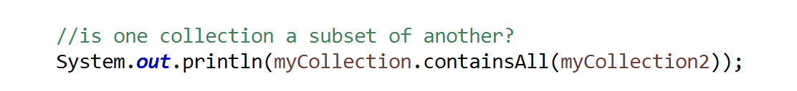
2. Find the intersection of two sets- (elements that are in both sets)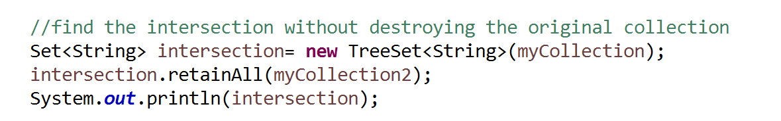
3. Find the union of two sets- (adding two sets together) 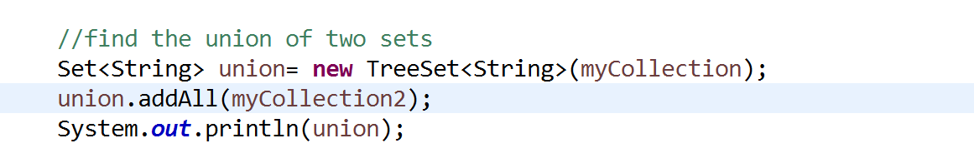
4. Find the difference of two sets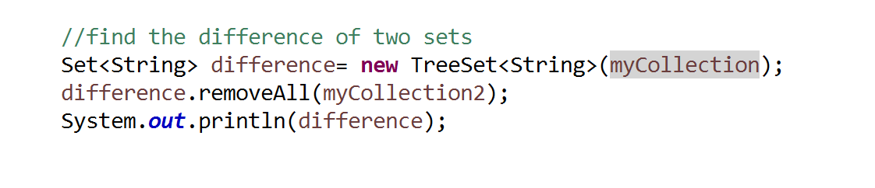
5. In lab 13 we created a Book class, I want a collection of books, what type of collection should they be? An ArrayList or a TreeSet?
6. Add the following books into your Collection
   1. *Rachel's Legacy* Thomas, Julie
   2. Bulibasha Ihimaera, Witi
   3. ChappyGrace, Patricia
   4. Wild Pork and WatercressCrump, Barry
   5. The Invisible MileCoventry, David
   6. Dad ArtWilkins, Damien
   7. The Antipodeans McGee, Greg
   8. AbsenceKing, Joanna
7. Print to check they are all in and they come out sorted by title. How does the TreeSort know what field to sort on?
8. Add in the following two books
   1. *Taken*, O’Callagan, Sue
   2. *Taken*, Crais, Robert
9. Did they both go in? How will you fix the Book class so that the books still come out in title order but the above two books are not classed as the same book?

Maps

1. Create a TreeMap of the makes of cars that you and your friends have owned. 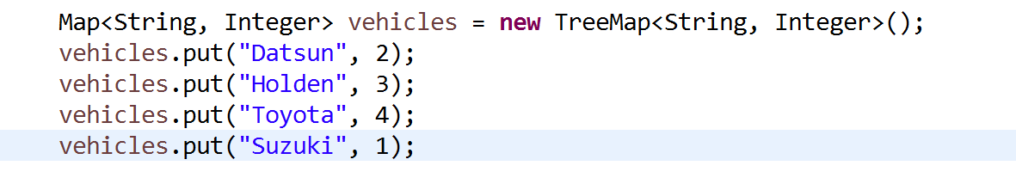
2. Print this map.
3. Iterate over this map using the keySet method   
   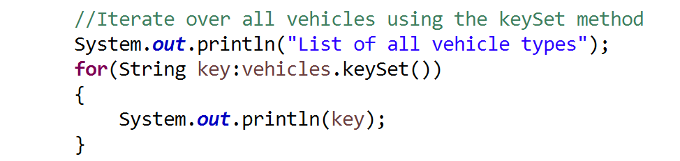
4. Calculate the total number of vehicles by looping around the values view 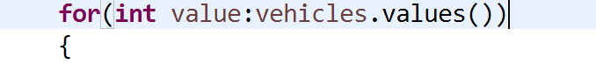
5. Ask a user which vehicle they would like information on eg Toyota  
   check if that key is present with the vehicles.containskey method  
   if its present get the corresponding value with the get method

Super Challenge:

Create an array of strings, loop through the array creating a map that gives you the frequency of each word.

**Super Super** challenge can you do this to the threebears file?